**Digital Marketing Services**

* Digital Marketing
* Digital campaign
* E-Commerce Development
* Web Development (Customize web Development)
* Revamping
* Branding and Creative
* Mobile App development
* SEO (Search Engine Optimization)
* Logo Designing
* Brochure Designing
* Content Writing
* SMM
* SEM
* Affiliate marketing
* Email Marketing
* Pay per click
* Digital Marketing

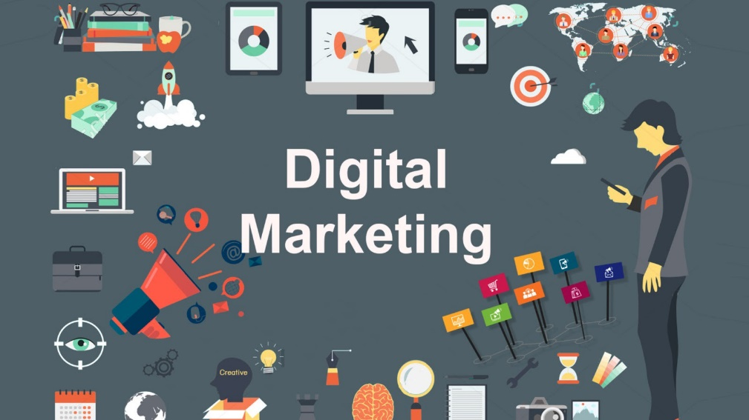

Digital marketing is the marketing of products or services using digital technologies, mainly on the Internet, but also including mobile phones, display advertising, and any other digital medium.

The ability to reach a global marketplace. You can save money and reach more customers for less money than traditional marketing methods. Get to know your audience and allow them to know you personally which can help to create brand loyalty. You can track responses to your marketing efforts immediately.

Digital marketing allows small businesses to compete with a much smaller advertising budget. When managed effectively, it gives them laser-focused control over where and how they spend their money. When you have this kind of control and the data to support decisions, you make smarter ones.

**Tagline:-**

* **We Settle Your Business**
* **Show Attitude of Your life**
* **Give me name I Will Make it a Brand**
* **Bringing Action to your brands**
* Digital Campaign

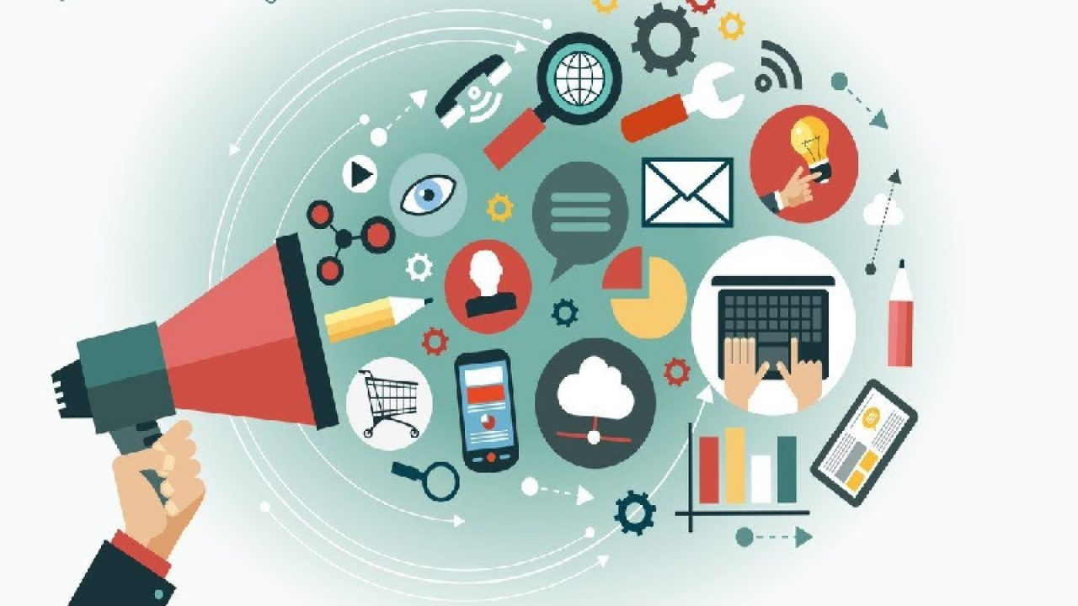

A digital marketing campaign is an online marketing effort put forward by a company to drive engagement, conversions, traffic, or revenue. The campaign ties in with the overarching goals of the organization and includes one or more digital channels in the efforts.

When small businesses get started, their focus is often on how to get their first group of customers through the door. They may rely on traditional forms of advertising, such as print ads and coupon mailers or even big signs on the side of the road. They may trust that since they know they offer a good product or service, it’s only a matter of time until customers will find their way to them.

While this strategy may bring in a trickle of business, there is a better and easier way. Small businesses should consider the huge marketplace of prospects online. No small business, no matter how new, should overlook this vast marketplace.

**Tagline:-**

* **The best marketing doesn’t feel like marketing.**
* **Think like a publisher, not a marketer.**
* E-Commerce Development

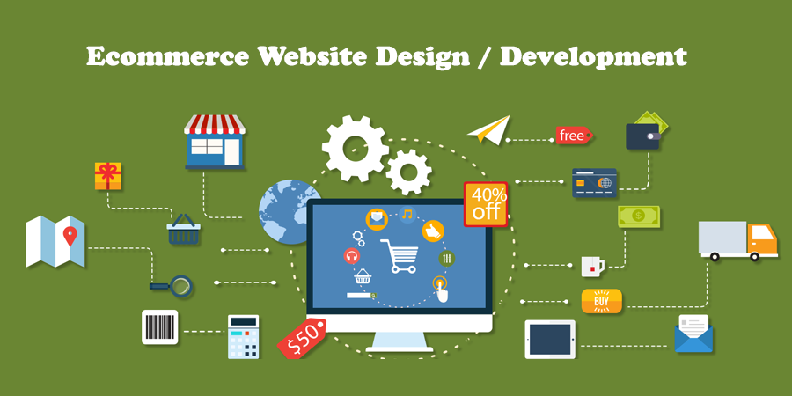

With the help of ecommerce web design you get an opportunity to have your products and services available to customers 24 hours. It gives a good exposure to your business and help you to reach out to potential customers. Since most of the people prefer to shop online due to paucity of time, you can easily make more revenue. With the help of an e-commerce website people can select and buy desired products anytime. They can pay easily through credit cards or other payment options available in website.

When it comes to buying gifts for your family and friends, an ecommerce shopping cart is what people prefer these days. Almost everything is available over internet. You just need to visit the website, select a product, add it in your shopping cart and pay. The gift will be delivered to the mentioned destination on time. Is not that simple and hassle free?

Another feature of an e-commerce website is that you can save an item in your 'wishlist' and buy it later. Thus, you do not have to go through the procedure of searching the product again as it is already saved in your list. This is why e-commerce websites are so user-friendly. For those wondering about the delivery of products and issues related to it, here is how it works.

Since the whole process of purchasing things takes place online, people sometimes doubt about the timely delivery of the products. In case your requested product does not reach you or reaches late, you can make a complaint at the 'goods return' section. The required measures will be taken then to ensure you get what you ordered for.

An e-commerce website also allows customers to post their comments regarding products and services. Thus, the owner of the website gets a feedback. He can use this feedback to improve the services and make them better. Keeping in touch with the customers also helps a business owner in the long run. Thus, ecommerce development is highly important in today's competitive environment.

Tagline:- 1)**Always ahead.,,,,,,,,,,,,,,,,,,,,,,** 2)**Feel-good shopping.**

* Web Development (Customize web Development)

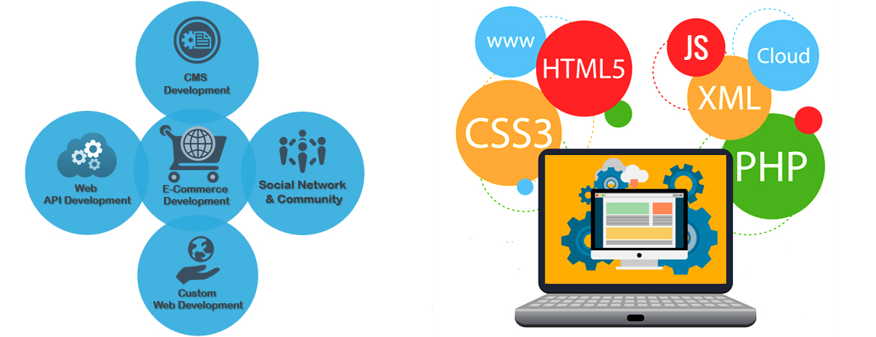

**A quality website is important for a business. Why?**

People search the internet for businesses, products, services, etc. The days of relying on phone books are long gone. If someone needs to find information, they are most likely turning to the internet to find it. When they search for something you offer or specifically for your business, you want to show up- and not just show up- but show up and look good.

Looking good is important because your website is often your first impression you give potential customers. If they found you through a search or through a link a friend gave them, your website will be your first point of contact with them. Before they even see your store or talk to your staff, they will see your website. You want that first impression to be a good one.

Your storefront and showroom look good, right? Why do they look good? Because you know customers will see them and form an opinion about the business based on them (in addition to factors such as customer service, quality, price, etc. of course). Think of your website as your digital storefront and showroom. People are looking at it and are forming an opinion about the business based on it. So make it look good!

**Tagline:-**

* **Get better looking.**
* **Making life easier.**
* Revamping(Experience the difference.)

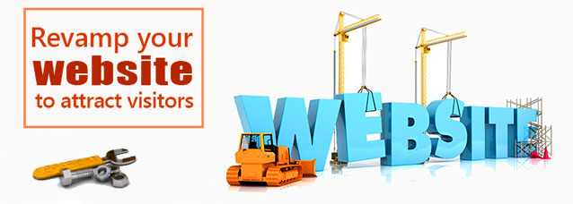

With the digital marketing space moving at a rapid pace, having an outdated website can have a negative impact on your business. Two questions we often hear from businesses we consult with about digital strategy are, “Do I need a website redesign to compete or rank better?” or, if we recommend a redesign, “Why do I need to redesign my website?”

These questions usually arise if the business is changing their branding or is having trouble ranking in Google, but there are many other reasons that a website redesign or revamp may be needed.

The reasons below vary in severity and, depending on which reason is identified, determines if your website just needs a quick design and structure update or a full redesign, build, and CMS migration.

6 REASONS TO REVAMP YOUR WEBSITE

* **YOUR WEBSITE IS NOT RESPONSIVE**
* **YOUR SITE HAS OUTDATED DESIGN**
* **YOUR SITE HAS OUTDATED TECHNOLOGY**
* **FOCUS OF YOUR BUSINESS HAS CHANGED**
* **YOUR WEBSITE IS NOT DELIVERING DESIRED RESULTS**
* **YOU HAVE CHANGED YOUR CONTENT STRATEGY**

**Reference…………….** <https://impressivesol.com/blogs/top-6-reasons-to-revamp-your-website/>

* Mobile App development

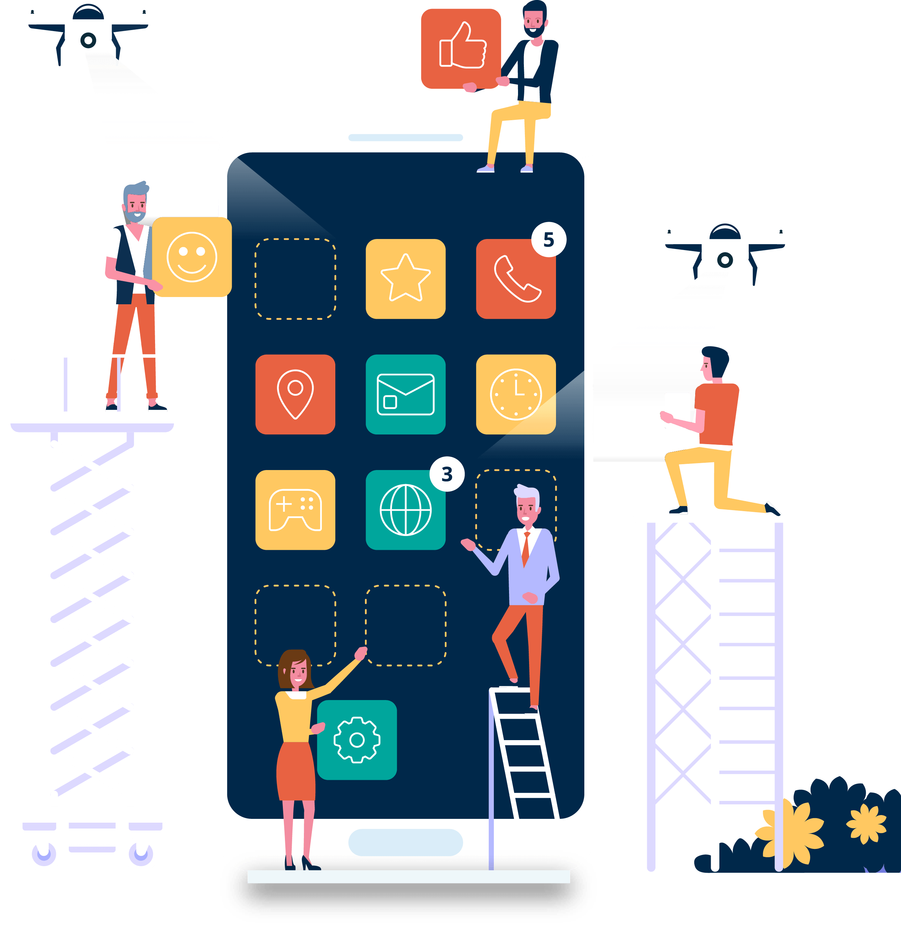

A mobile device has evolved from just a communication tool to a highly effective business tool over the years. As technology is advancing at lightning speed, with that people are getting more addicted to mobile phones, tablets & other smart devices. The Importance of Mobile Apps in Business has climbed the ladder to the top rapidly in past few years. Mobile devices changed the way businesses work. High speed data access & excellent user experience are the keys to the high growth. Mobile apps made it easier for users to get any business information at their fingertip and stay connected to their favourite brands. That’s why a lot of businesses are taking their presence to mobile platforms.

The mobile app market has reached close to $30 billion in revenue according to a study report. Irrespective of the huge number, the app market is still in early stages and has plenty to offer. Every business owner, small or big, must own up to the fact that with the current rate of technology adoption, no business should be marketed offline alone. Today, mobile marketing is more effective than ever and brings numerous benefits, even for small benefits. Owners of small businesses must adapt to technology trends and stand to gain by developing a mobile application for their business.

However, before a business jumps into the ocean of mobility, there are few questions which need to be answered.

**Tagline:- Your vision Your focus**

* Branding and Creative

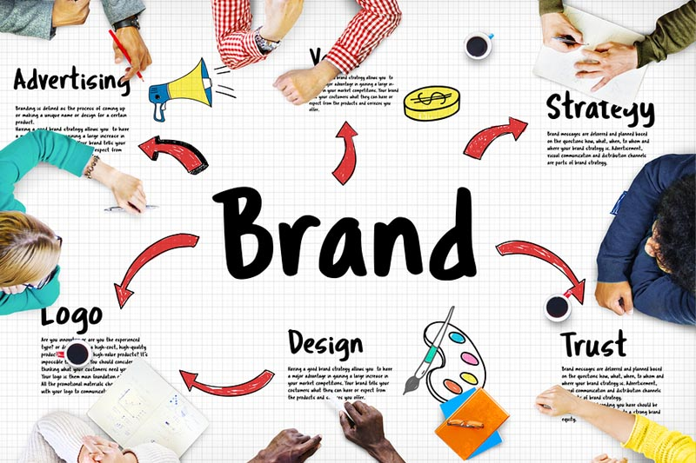

Branding, by definition, is a marketing practice in which a company creates a name, symbol or design that is easily identifiable as belonging to the company. This helps to identify a product and distinguish it from other products and services. Branding is important because not only is it what makes a memorable impression on consumers but it allows your customers and clients to know what to expect from your company. It is a way of distinguishing yourself from the competitors and clarifying what it is you offer that makes you the better choice. Your brand is built to be a true representation of who you are as a business, and how you wish to be perceived.

There are many areas that are used to develop a brand including advertising, customer service, promotional merchandise, reputation and logo. All of these elements work together to create one unique and (hopefully) attention-grabbing professional profile.

**Why Is Branding Important?**

Branding is absolutely critical to a business because of the overall impact it makes on your company. Branding can change how people perceive your brand, it can drive new business and increase brand awareness.

* SEO (Search Engine Optimization)

SEO is Google’s way of determining which sites deserve to rank highly for each query entered into its search engine. Without modern SEO, it would be extremely simple to manipulate the search results so that the site with the most links or the most pages—all easily generated by software—consistently ranked #1.

SEO is important because it keeps the search results fair. It reduces the ability to manipulate these results as much as possible, so that the sites appearing for each search are there because they deserve to be there. Hard work and a website that appeals to visitors correlate with high search engine rankings, so if your site meets these criteria, you’ll have a better chance at showing up in the results.

Users trust search engines, and achieving a top spot in search engine rankings signals to searchers that your site is a credible source. The higher you rank in results pages, the more clicks and traffic your site will generate. SEO also improves user experience, making it more likely for customers to become repeat buyers.

And SEO is cost-effective. Competitive industries can spend large amounts of money on paid website traffic. Of course, you can still purchase ad space, but if you’re working with a tight budget, SEO is a great way to drive qualified traffic to your site without directly paying for it.

**Tagline:-**

**Google Only loves you when everyone love you first**

**Today It’s not about getting traffic -it about get the targeted and relevant traffic**

* SEM(Social engine marketing)

SEM is a form of internet marketing that involves the promotion of website by increasing their visibility in search engine result page(SERs) primarily through paid Advertising

**Tagline:-**

* **Focus on how to be social , not how to do social**
* **Great Content deserves great ranking**
* SMM(Social Media Marketing)

SMM marketing is the used of social media platform to connect with your audience to build your brand increase sales and drive website traffic

**Tagline:- Social Media Create Communities not marketing**

* Affiliate Marketing

Affiliate marketing is the process of earning income every time you promote someone else’s products or services. If you generate a sale for the company, you get paid. If you don't generate a sale, you do not get paid.

Tagline:-

* Leads Market where Affiliates rule!
* Right Fit For Affiliates!
* Leads marketing has a new home.
* Pay per Click

PPC is an online advertising model in which advertisers pay each time a user clicks on one of their online ads. ... All of these searches trigger pay-per-click ads. In pay-per-click advertising, businesses running ads are only charged when a user actually clicks on their ad, hence the name “pay-per-click.”

Tagline:-

* Pay only for the work done
* Email Marketing

Marketing your products or services by email can be a fast, flexible and cost-effective way of reaching new customers and retaining existing customers by encouraging repeat website visits.

Email marketing can allow you to create targeted and personalised messages. This can help you to build meaningful relationships with your customers. It can also improve response rates to your direct marketing campaigns.

Tagline:-

* We Have Exactly What You Need.
* There is no Substitute.
* Logo Designing

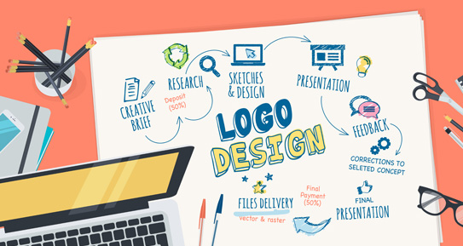

* Brochure Designing

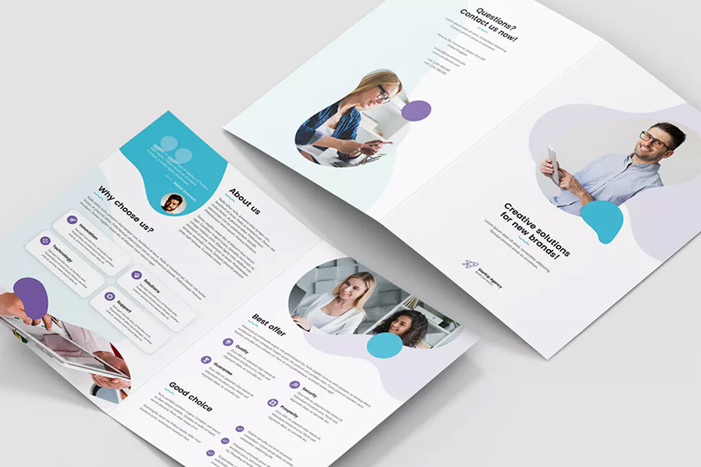

* Content Writing

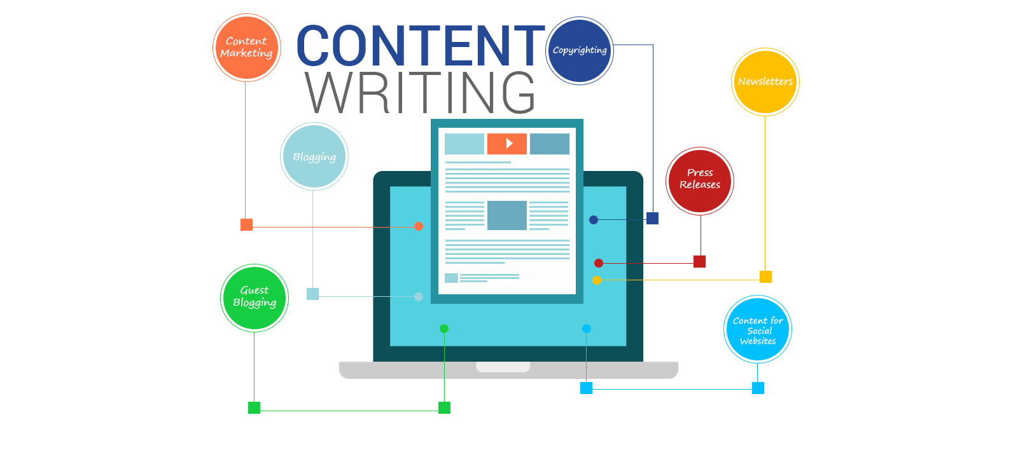

**Tagline:-**

* “Content marketing is a commitment, not a campaign.”